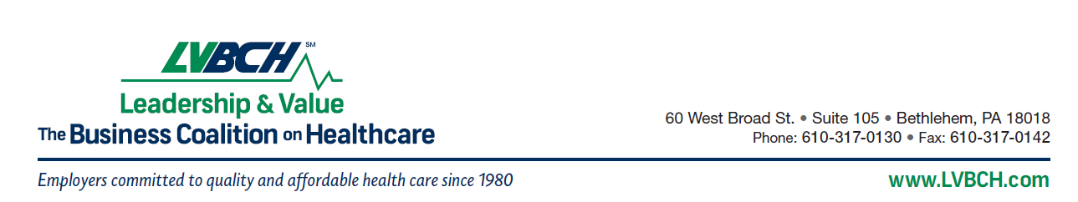
FOR IMMEDIATE RELEASE May 21, 2013

For more information, contact:
Tom Croyle
L V B C H
Telephone: (610) 317-0130
Fax: (610) 317-0142
E-mail: tcroyle@lvbch.com

LVBCH Announces 2013 Innovation Award Winners
East Penn Manufacturing-Reading Health System-Capital BlueCross-Banyan Consulting

Bethlehem, PA (May 21, 2013) For the fourth consecutive year, the Lehigh Valley Business Coalition on Healthcare (LVBCH) presented an innovation award to an employer who best demonstrated a unique approach to employee health, wellness and productivity. East Penn Manufacturing (Lyon Station, PA) along with its collaborative partners, Reading Health System, Capital BlueCross and Banyan Consulting were also cited for their role in working with East Penn to implement the “Primary Care Plus™” program.

Primary Care Plus is the Reading Health System’s new approach to primary care that focuses on improved quality of care through prevention and clinically integrated services. East Penn employees and their family members enrolled in the Capital Blue Cross HMO who selects a Reading Health System Primary Care Physician benefit from an enhanced level of services. Banyan Consulting provides data analytics that will help measure the effectiveness of Primary Care Plus and identify opportunities to improve patient health.
In commenting on the awards, Tom Croyle, LVBCH president, said, “We are excited to be able to recognize this unique effort in Berks County reflecting an innovative approach to improving the health and productivity of the employees of East Penn Manufacturing. We are also pleased to recognize Reading Health System, Capital BlueCross and Banyan Consulting for their role in this collaborative effort.”
Accepting for their respective organizations were Bob Johnston (East Penn Manufacturing), Richard “Rick” Jones (Reading Health System), Tracy Onorofsky (Capital BlueCross), and Scott Fair (Banyan Consulting). The awards were presented at the Coalition’s 2013 Annual Conference.

-0-
About LVBCH
LVBCH is a multi-state, not-for-profit coalition of employers striving to provide the finest health care coverage possible for their employees, in the most economical fashion. The Coalition’s mission is to improve the delivery, cost and quality of health care in our communities through: Collective employer action; Quality and data initiatives; Value based purchasing; and, Providing forums for the exchange of information, ideas and resources. The Coalition is also a member of the National Business Coalition on Health, the National Quality Forum and The Leapfrog Group. For more information, visit www.LVBCH.com.

